**Principal Functional systems in a business**

These are specialized software systems that focus on specific functional areas within an organization, such as finance, human resources, supply chain management, customer relationship management (CRM), or manufacturing. Each system typically addresses the specific needs of the particular department or function it serves.

There are nine principal functional systems

* Purchasing
* Receiving
* Inventory
* Production
* Sales
* Distribution
* Billing
* Collection
* Paying

**MIS (MANAGEMENT INFORMATION SYSTEM) :-**

A management information system (MIS) is a [computer](https://www.javatpoint.com/what-is-computer) system of hardware and software that acts as the foundation for an organization's operations. An MIS collects data from various online systems to support management decision-making, analyses the information, and reports data.

A management information system (MIS) is a computerized financial data database set up and designed to generate regular reports on operations for all levels of management within a firm**. The MIS often compares "actual" data to "planned" outcomes and results from the previous year to gauge progress toward goals.**

**Components of MIS**

* + People
  + Business procedures
  + Data
  + Hardware
  + Software

## Objective of MIS

## Data Capturing

## Processing of Data

## Storage of Information

## Retrieval of Information

## Dissemination of Information

## Characteristics of MIS

* + System approach
  + Management-oriented
  + According to requirements
  + Future-focused
  + Integrated
  + Common data flows
  + Long-term planning
  + Relevant relationship between subsystem planning
  + Central database

**Advantages of MIS**

* + Facilitates planning
  + Minimizes Information Overload
  + MIS Encourages Decentralization
  + **Brings Coordination**
  + **Makes Control Easier**

**Disadvantages of MIS**

* + expensive to set up
  + **Lack of Flexibility to Update Itself**
  + **Risk of fraud**
  + **Takes into Account only Qualitative Factors**
  + **Heavy reliance on technology**

**Deployment Process:** [Process of Management Information System Development | Process of MIS Development (prsunotes.in)](https://www.prsunotes.in/post/process-of-management-information-system-development)

**Characteristics of Decision Support System**

* + Handle Large Amount of Data From Different Sources
  + Provide Report & Presentation Flexibility
  + Offer Both Textual & Graphical Orientation
  + Support Drill-Down Analysis
  + Perform Complex, analysis
  + Goal Seeking Analysis
  + what-if analysis

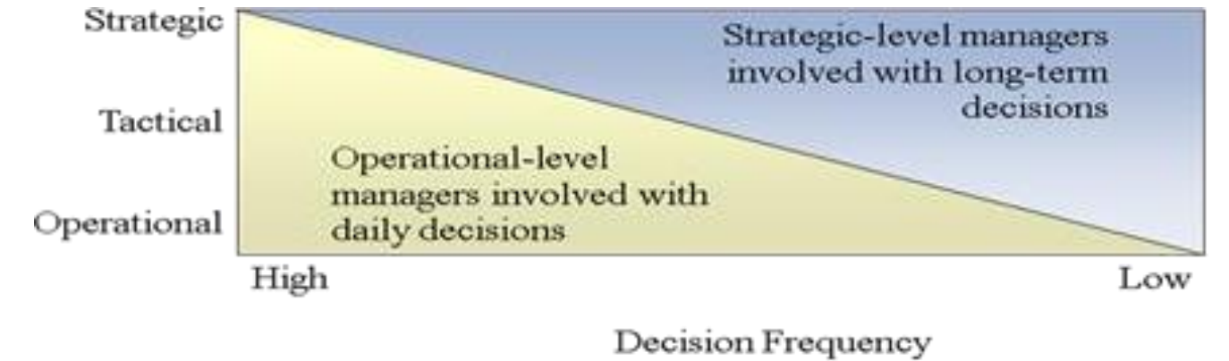

**Limitation of DSS:**

* small memories and limited storage capacities
* It is slow
* limited information sharing(unconnnectes)

**Principal Function System in Business**

The principal function system typically refers to the core systems or processes that are essential for the operation and management of the organization. These systems are fundamental to the business's activities and are often integrated to support various functions across departments. The principal function system may vary depending on the nature of the business, industry, and organizational structure.

Ex,

* + - Enterprise Resource Planning (ERP) System
    - Customer Relationship Management (CRM) System
    - Supply Chain Management (SCM) System
    - Financial Management System
    - Human Resource Management System (HRMS)

**Product flow** refers to the movement of physical goods or services through various stages of production, distribution, and consumption within a business or across its supply chain. It involves activities such as procurement, manufacturing, inventory management, transportation, and delivery. The goal of optimizing product flow is to minimize costs, reduce lead times, improve quality, and enhance customer

**Information flow** refers to the movement of data, knowledge, or instructions within and between different components of a business information system. It encompasses the transmission, processing, storage, and retrieval of information to support decision-making, communication, collaboration, and coordination among stakeholders. Information flow is crucial for maintaining visibility, control, and efficiency in business operations.

**Principal Document Associated with Information Flow**

The principal document associated with information flow in business information systems is typically referred to as the "Information Flow Diagram" or "Data Flow Diagram (DFD)."

A DFD is a graphical representation of the flow of data within a system. It illustrates how data moves from external entities into the system, gets processed, and then flows out to other external entities or storage locations. DFDs are commonly used during the analysis and design phases of system development to understand the information requirements, identify processes, and define data transformations.